NEXTAG COMPANY

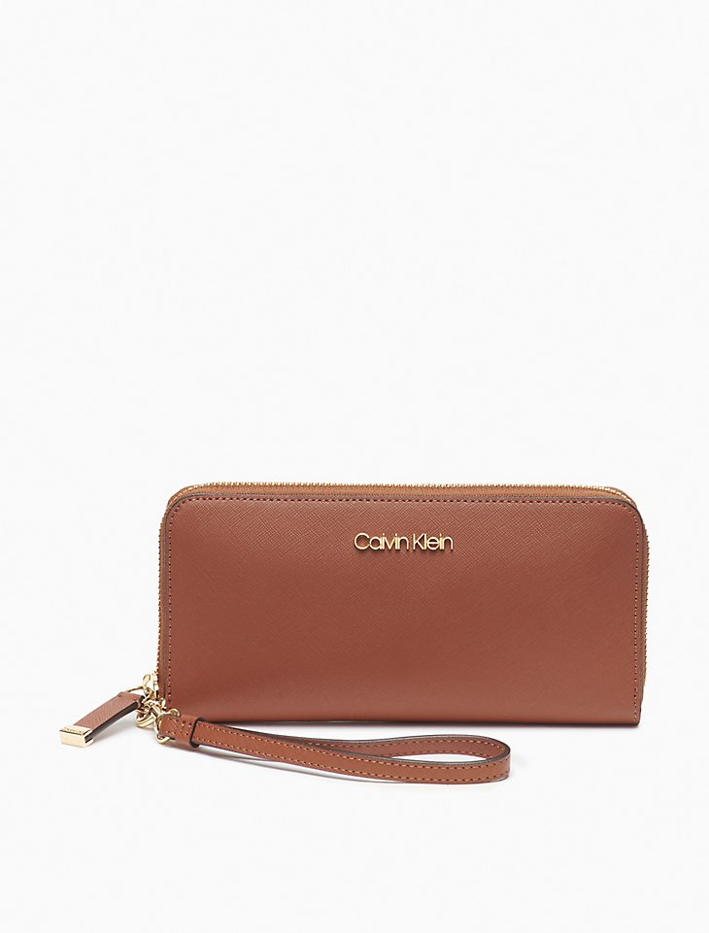CALVIN KEILN - SAFFIANO LEATHER ZIP CONTINENTAL WALLET

##### **Detail**

Designed with distinct saffiano leather, this elegant zip continental wallet is made with a zip around closure, a signature logo plaque, an interior center zip divider pocket, multiple bill slots and card slots in a fully lined interior.

• Saffiano leather zip continental wallet

• Zip-around closure

• Logo plaque

• Interior center zip divider pocket

• 2 large bill slots + 2 open slots

• 8 card slots

• Fully lined

Style #: 37204201-208   
Universal Style #: H8JQ18VD

##### **CARE & COMPOSITION**

• Leather

• Imported